Raising Blues, Greens, and Purples

By Jim Gourlie and Frank Orteca

Raising Purples, Blues and Greens can be fun and rewarding, but they all have their own special road maps of genetics. If you choose them properly, though, you can improve the strain greatly. All three of these color strains are very similar with a few exceptions. When describing (according to IFGA standards) the qualities that make up each of these color strains, the same qualities will generally apply to each color. And yes that is an Albino Purple in the picture above. But that is for another story!
Examples of Desirable Traits: A good Green Delta should have a large well shaped body with as much green in it as possible with a good distinct green caudal with matching dorsal. Color should have as much intensity as possible." These same traits are desirable for blues and purples as well. All three of these strains will complement each other in a fish room. But it is important to watch what strains you cross. Typically you can cross blue to purple, purple to blue, green to purple, purple to green, with very good results. The strains NOT to cross would be blue to green or green to blue. In most cases this will give you a turquoise fish that won't do well on the show bench in blue or the green class.

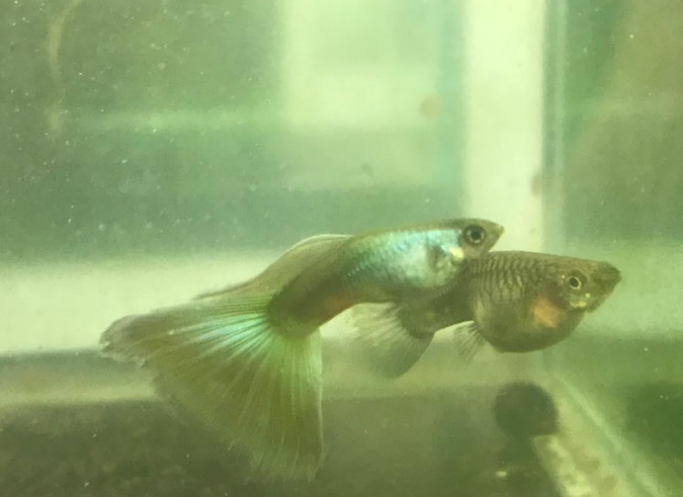

The crossing of these strains is what most breeders feel will give the fish a lot of iridescence. There have been many good blues, purples and greens that did not do well on the show bench because their color was fiat. This has occurred more often with the purples. You may have seen some charcoal murky purple fish on the show bench. When crossing blues and purples, you have to watch against the colors becoming too dark. Some beautiful purples have been disqualified on the show bench for not being purple because their color was black purple. There have also been some brilliant blues that have been knocked down on the show bench because their dorsals were too dark (charcoal blue/ black) and their caudals were vibrant blue.
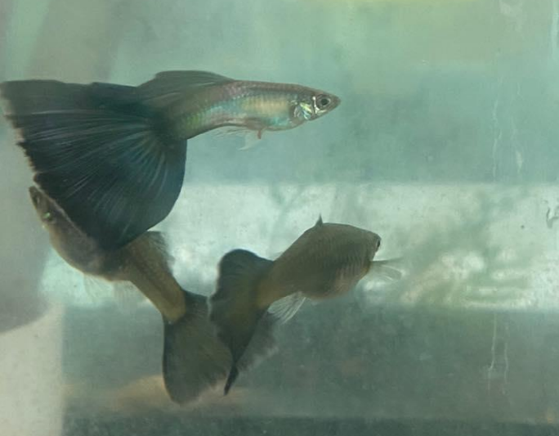

The benefits of crossing blues and purples is that you can improve the intensity and the iridescence of each color. When crossing blues and purples, please be aware that the first generation (F1) may contain blues, purples and lighter and darker shades of each. You will have to cull to get to the desirable results. The benefits of crossing the blue and purples are many. You can improve the intensity and iridescence of each color. Also, it goes without saying that by using true breeding strains to make the cross, the better the success rate.
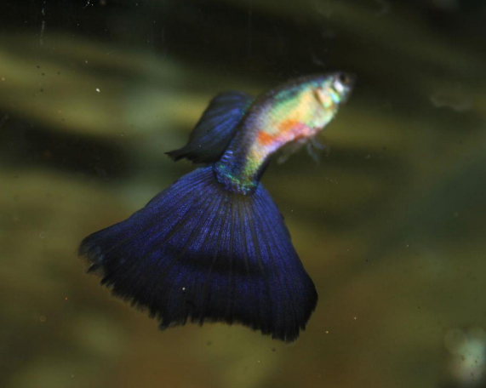
Out of the three color strains, most breeders would agree that greens are the hardest to keep up to snuff. Their color can change in an instant from a green to a blue cast, or even a silver gray cast. Greens, when crossed with purples, can give your fish more color intensity, with the possibility of increased size.
If the green is dominate, your F1 will be green. Keep in mind that when you inbreed the F2 generation, you may have some purples pop out as well. Another thing to consider when crossing greens, is that you will have varied results with each kind of strain. This is because of the many different types of Green strains; i.e. Parrish, Hutter, Russell, etc. To give an example, let's say you use a dark purple in your cross. The results will be different than if you had used a lavender purple Fish. This statement can also be applied to blues as well, that is, light blue vs. dark blue.
The real trick with the greens is very much like what you have to do with the red strains. The trick is to keep the colors intense and pure year after year!

